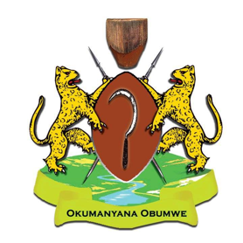

International Community of Banyakigezi
14th Annual Convention & Annual General Meeting
Kingston upon Thames, London, United Kingdom

22nd – 25th July 2016

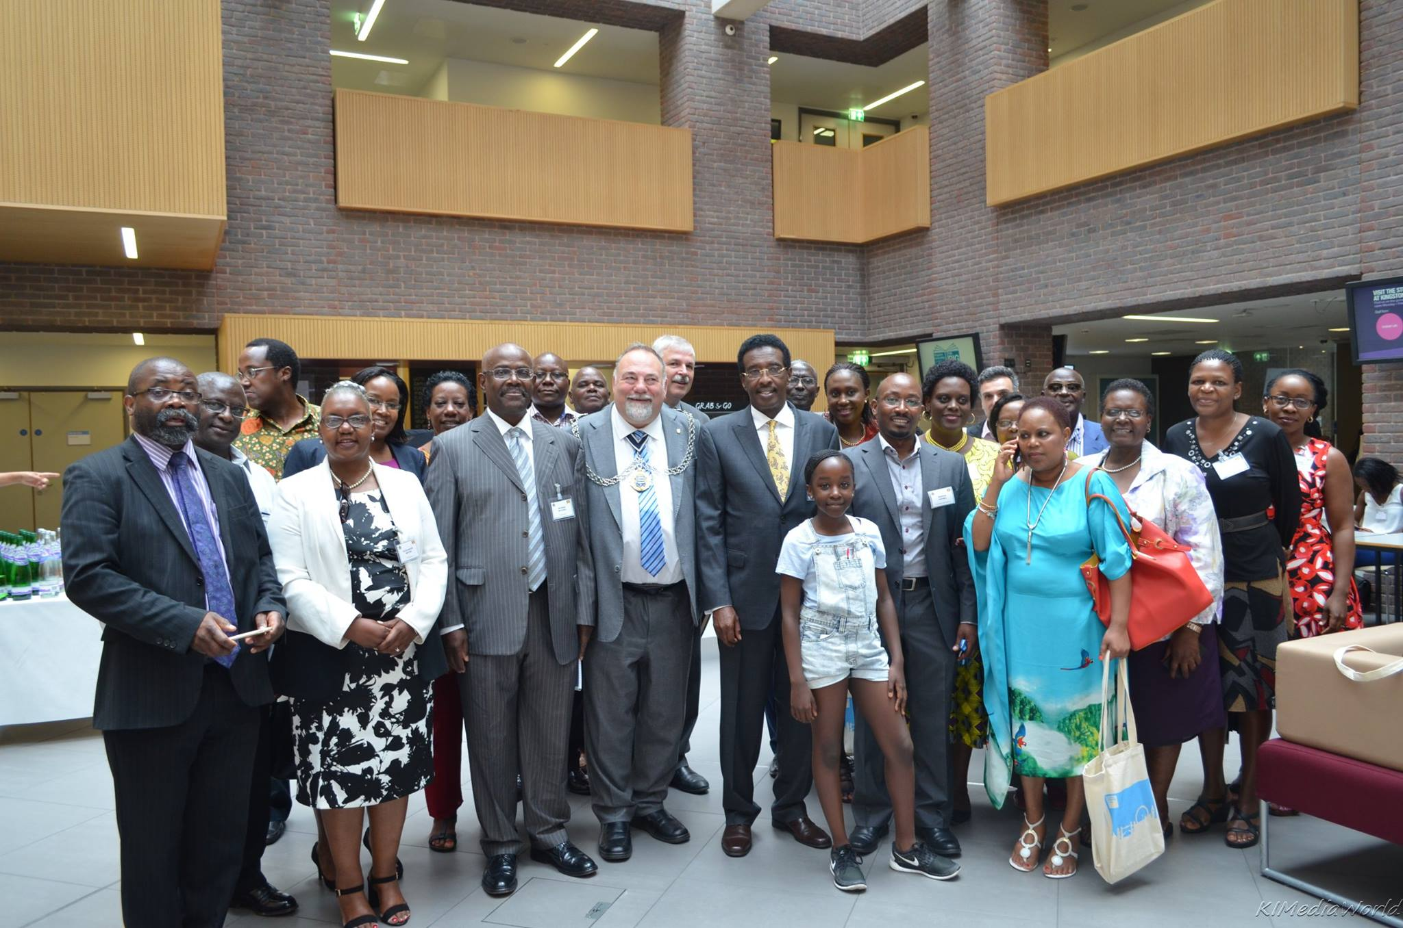

- Introduction
The 14th Convention and Annual General Meeting of the International Community of Banyakigezi (ICOB) were held at the School of Business, Kingston University, London, United Kingdom from Friday 22nd July to Sunday 24th July 2016.

The theme for this year’s Convention was “Harnessing self-employment / Small business ownership to improve house hold incomes.”

The objectives of the Convention were to:
- Review the journey of ICOB since its inception 13 years ago;
- Agree on actions to scale up the growth of the organisation;
- Share ideas and strategies for improving the economic conditions of Banyakigezi;
- Network, in order to foster social support and mutual help;
- Fundraise for the Kigezi Education Fund;
- Celebrate and promote our culture;
- Stimulate self-expression, happiness and health.

- DAY 1: Official Opening and Introduction
The meeting started at 10 a.m. on Friday 22nd July 2016 with welcome and introduction to ICOB 2016 by Mr. Dennis Aguma, Chairman of Community of Banyakigezi, UK Chapter (COB, UK). Mr. Aguma introduced Professor Ronald Tuninga, Dean, Faculty of Business and Law and Pro Vice Chancellor, Enterprise Faculty Management, who welcomed delegates and speakers to Kingston Business School and the city of London.
Prof. Tuninga welcomed and introduced Councillor Geoff Austin, the Lord Mayor of the Royal Borough of Kingston Upon Thames, who welcomed delegates to his Borough and gave a fascinating historical background to Kingston.
Ms. Beatrice Hamujuni, the vice president of ICOB, gave welcome remarks and introduced Maj. Gen. Jim Muhwezi who represented Rt. Hon. Dr. Ruhakana Rugunda, the Prime minister of Uganda. Dr. Rugunda, who had been invited as guest of honour, was unable to attend due to other commitments.

  - Presentation: A micro and macro-economic story of Kigezi
Dr. Peter Ngategize of Ministry of Finance Uganda and Chairman ICOB Uganda Chapter, presented the micro and macroeconomic story of Kigezi whilst Prof. George Saridakis and Dr. Rosemary Athayde of Kingstone University presented, ‘The effects of self-employment/small business ownership on household incomes”.
The presentations were followed by an open panel discussion moderated by Dr. Wilber Sabiiti of University of St. Andrews. Beatrice Hamujuni-Smith an MD and business owner IRC Care Services and Yousuf Al-Minji MD and business owner Salabed, joined Peter, George and Rosemary as discussants.
Submissions from both discussants and the audience put the presentations into context. The following were highlights from the discussion:
Kigezi is highly endowed with resources and we should harness them for economic development of the region, said Dr. Ngategize.
“Opportunities are all around you. Take them up”, said Yousuf.
“Look for something you are passionate about and pursue it”, said Beatrice.
Presence of more opportunity-based than necessity–based entrepreneurs implies the economy has developed and no longer based on meeting basic necessities. “The Ugandan economy should aim at creating more opportunity based entrepreneurs”, said Dr. Athayde.
Highlight role models in business to inspire entrepreneurship spirit among young people.
“We are all African and we should see ourselves as such, not on tribal basis”, said Hon. Muhwezi.
Don’t give people fish but teach them how to fish so that they eat fish forever. So handing out more districts will not uplift people from poverty in Uganda.

Resolutions:
- Invest in Kigezi: Motivate and empower Banyakigezi at home and the Diaspora to accelerate the economic development of Kigezi by investing in areas like tourism, mining, education and health.
- Entrepreneurship and enterprise: Lobby the government of Uganda to create an entrepreneurial and enterprise enabling environment through eliminating corruption to allow level ground for business, putting in place systems including favourable financial products and formulating policies/entrepreneurship blue prints that enable business to thrive, and exercising good will to promote public private partnerships.
- Education: The Banyakigezi to work and lobby for development of a curriculum that is integrated with the social and economic needs and realities of Kigezi in particular, and Uganda in general.
- Economic empowerment: ICOB to lobby the Government of Uganda and investors to increase economic investment in Kigezi, including creation of social enterprises that empower households and prevent ills such as lack of sanitary pads for girls that fan school dropout.
- Human resource: Lobby the Government of Uganda to make use of the home grown and diaspora talent to fill skill gaps in education and health. Two propositions were made to address human resource shortage:
- Institute flexible retirement age for highly skilled professionals: To clarify this an example was given of medical doctors who are retired at 60 years and go ahead to work in the private sector, leaving public hospitals with no specialist or doctor at all.
- Making use of experts in the diaspora: A system could be put in place where the Kigezi (and Uganda at large) diaspora can be brought on board to help with education and health services during their holidays in Uganda. Many Banyakigezi experts in the diaspora are willing to give free lectures and hands-on training in Universities and colleges, clinics, legal advice etc
- Health: Lobby the Uganda Government and the district governments to adopt and promote a holistic approach to health problems, including:
  - Dangers of addiction such as alcohol and drug abuse
  - Mental health
  - Coping mechanisms with post-traumatic disorders
  - The reasons for school dropout such as early marriage, lack of sanitary pads for girls
  - Sexual and reproductive health.
- Culture: Proactively advocate the preservation of the cultural heritage of Kigezi through building of Kigezi museum, documentation and publication of our history and cultural heritage for posterity.
  - What kind of ICOB would you like to see?
Mr. Emmanuel Turyamuhaki, the Master of Ceremonies, introduced the speakers, Dr Muniini Mulera.
Dr. Munini Mulera presented a paper titled “ICOB@13: Teen Challenge,” in which he gave a comprehensive narrative of the origins of ICOB, the journey so far and future directions. He emphasized that Omugurusi Paulo Ngorogoza’s dream runs in the blood of ICOB: ‘’Gatagata gatebirwe owa baine embeho”. Once a Munyakigezi always Omunyakigezi. ICOB isn’t for you or me but for all of us. Political ideologies or religious belief should never divide us.
He reiterated ICOB’s policy of non-partisanship. He explained that our Bylaws and the laws that govern a United States Section 501(c) 3 tax-exempt organization require us to treat all politicians and political parties equally. We must not show partiality.

Dr. Mulera recommended that ICOB should:
- adopt and implement corporate governance;
- insist on transparency and accountability by their leaders;
- develop and adopt a comprehensive Strategic Plan;
- ensure year-round activities, including ongoing fundraising;
- ensure that the organization is a home for all Banyakigezi, not just those with money and high status.

Mr. Dennis Aguma presented a corporate strategy for ICOB, which he said needs organisation, strong internal communication, clear timeline and branding where necessary. He proposed a Kigezi Day during which Banyakigezi all over the world would engage in activities that celebrate our heritage and enable networking and fundraising.
The presentations were followed by an open discussion moderated by Dr. Wilber Sabiiti with discussants, Dr. Muniini K. Mulera, Mrs Lilliane Rumanyika Mugisha, Mr. Dennis Aguma and Dr. Peter Ngategize.

Resolutions:
- ICOB governance: ICOB should adopt and implement corporate governance to increase efficiency and productivity and ensure transparency, accountability and compliance with the organization’s Bylaws and the laws of the United States of America. The ICOB executive and board in collaboration with chapter leadership to work out modalities to implement this resolution.
- Charitable organization status of ICOB Chapters: All ICOB Chapters to seek registration as charitable, tax-exempt organizations in their respective jurisdictions in order to access resources from national and international funding bodies.
- Promote unity and broad based approach: This entails the grassroots strategy that engages all Banyakigezi and chapter based from bottom-up to ICOB Apex. Activities such as Kigezi awards, Kigezi Day and Kigezi walk will go a long way in cementing the unity between Banyakigezi and increasing the relevance of ICOB to an ordinary person living in Kigezi today.
- Encouraging chapter based conventions will increase the level of participation of Banyakigezi who cannot afford traveling to UK, Canada or USA. Instituting a Kigezi fund will enable a wide participation of all Banyakigezi and allow ICOB to respond to other calls such as health, educational scholarships and entrepreneurship to mention a few.
- Kigezi Education Fund (KEF): This fund should continue to be the flagship program of ICOB, with continued focus on supporting technical and other vocational education in Kigezi. ICOB should scale up efforts to increase year-round donations to the Fund.

Speaking after the morning’s presentations, Maj. Gen. Muhwezi commended Dr. Mulera's presentation not only for its richness in giving the history of ICOB but also bringing out the fundamental principles of ICOB which we all cherish. He condemned those who tried to politicise ICOB in the past. He specifically condemned those who had falsely alleged on social media that the Uganda Government had given money to Ms. Ruth Ndyabahika.

He appealed to all to jealously guard the principles of ICOB as a non-profit, non-partisan organization. He thanked Dr. Mulera for pledging to uphold these principles.

Afternoon session

- Day 2: ICOB Annual General Meeting for 2016
The ICOB Annual General Meeting (AGM) 2016 was on Saturday 23rd July 2016 at 2:00pm.

  - Board Members and Executive Officers Present:

Beatrice Hamujuni-Smith, Ruth Kyamatuuku, Peninah Ngategize, Andrew Katarikawe and Lilliane Rumanyika-Mugisha

Board Members and Executive Officers absent with apologies: Ruth Ndyabahika, Frank Byamugisha, Judi Nkusi, Margaret Tumusiime, Grace Kobusingye, Kwame Rugunda, Andrew Hakiza, Elvis Muhaabwa.

Members present:
(Full list attached Anex14.)

Chairperson of the Meeting: Ms. Beatrice Hamujuni-Smith, Vice President of ICOB.

Minutes of the Annual General Meeting of 2015, which was held in Dallas Texas, USA, were adopted.

  - Balance of accounts report:
Prior to the meeting, it was a greed by the executive and board members present that only the Organization’s account balance would be presented since the balance of account report was incomplete. The balance of account, as submitted by the Acting Treasurer, was presented by the vice president. (Copy attached)

  - Chapter reports:
A report of the UK chapter was given by Ms. Ruth Kyamatuku, the Canada Chapter report was given by Ms. Lilliane Rumanyika-Mugisha and the Uganda Chapter report was given by Dr Peter Ngategize. There was no report from the US chapter.
A summary of ICOB by Laws regarding nominations and elections was presented by Mr. Andrew Katarikawe.

  - Elections:
President: Dr. Muniini K. Mulera was the only candidate for president. The members present unanimously agreed that Dr. Mulera be declared the next president of ICOB.

The Vice president declared Dr. Mulera elected president of ICOB.

Secretary General: No election because there was no candidate.

Treasurer: No election because there was no candidate.

Board Member: No election because there was no candidate.

  - Swearing in of the president:
The ICOB leaders present and the representatives of the Uganda government were invited by the new President to join him and hold hands in unity. The new president then stated: “I solemnly affirm that I will faithfully execute the Office of President of ICOB, and will, to the best of my ability, preserve, protect and abide by the Bylaws of the International Community of Banyakigezi.”

Speaking on behalf of the Uganda Government delegation, Maj. Gen. Jim Muhwezi expressed his pleasure at the spirit of unity that had been displayed throughout the meeting and concurred with Dr. Mulera’s message that ICOB was and must remain non-partisan.

”ICOB must remain non-partisan and a home of all Banyakigezi and the friends of Kigezi regardless of their political or other inclinations,” Muhwezi emphasized.

There being no other business, the meeting was adjourned at 5:00pm.

  - Evening session Dinner dance and Fundraising for KEF
This was a well-attended gala event, held in the Ballroom of the Holiday Inn, Surbiton, Kingston upon Thames, with cultural dancing, live music, poems and dance performance by the young people and children.

Mr. Emmanuel Turyamuhaki, the Master of Ceremonies, did an outstanding job of ensuring a smooth flow of the evening’s program.

Fundraising: Mr. Cliff Musiimenta gave a brief, well-articulated presentation on the projects that have been funded by KEF. He then did an excellent job of presiding over the fundraising appeal that generated the following:

- DAY 3

  - Worship:
A one-hour ecumenical Christian service was held at the Holiday Inn, starting at 10:00 a.m. Personal testimonies were shared and the sermon was delivered by Dr. Shekaniya Matsiko.

  - Tour of London:
Delegates were taken on a bus tour of key attractions in London.

  - Barbeque:
Delegates traveled to Boxhill Park in the Surrey country side for a BBQ, games, fun and fellowship.

  - Business discussion at the Barbecue:
Dr. Shekaniya Katono Matsiko, a Consultant Physician in the UK presented a proposal that had come out of a discussion between him, Dr. Judi Orikiriza, a Munyakigezi paediatrician studying in Dublin, Ireland and Dr. Muniini K. Mulera, a Munyakigezi paediatrician in Toronto, Canada.

Having listened to tales of visits to healthcare facilities in the Kigezi sub-region and the state of health care in the country, as well as media reports including those from the last election, the three physicians wished to make the following observations:
- Healthcare provision has improved exponentially over the past few years.
- Costs and expectations rise exponentially faster than the available resources, leading to a funding gap. This funding gap is in part responsible for the woeful state of healthcare in the country.
- ICOB has been encouraged by the recent instances where government and opposition parties have come together on some matters of national interest like in the AU chair candidacy of Dr. Specioza Wandira Kazibwe.
- ICOB therefore would like to encourage the government and the opposition parties to approach the resolution of the funding gap in healthcare by a bipartisan approach.
- Before the abandonment of "cost sharing" on account of political expediency, services were better run, morale among staff was good from health centres to Mulago National Referral Hospital.
- "Free healthcare" in some places means "no healthcare".

Dr. Judy Orikiriza, a paediatrician based in Dublin, Ireland, shared her experience working in the health care service in Uganda. After discussion by the members, the following motion was tabled by Dr. Matsiko:
“The ICOB Convention 2016 resolves to lobby and encourage the Government of Uganda and the opposition political parties, especially the Forum for Democratic Change (FDC), to "de-politicize" healthcare and take a bipartisan approach to finding the solution to the healthcare funding gap including ‘cost sharing’”

Seconded by Dr. Judi Orikiriza.
Motion carried unanimously.

- Conclusion
The three-day convention ended on a great note of unity, strength and enthusiasm to be doers and implementers of the convention’s resolutions.

Appendices

Annex 1: LIST OF ATTENDANTS (TO BE ADDED)

Annex 2: Registration List

Annex 3: A micro and macro-economic story of Kigezi by Dr Ngantegize

Annex 4: “The effects of self-employment/small business ownership on household incomes”, by Prof. George Saridakis of Kingston University

Annex 5: “The effects of self-employment/small business ownership on household incomes”, by Dr. Rosemary Athayde of Kingston University

Annex 6: A paper titled “ICOB@13: Teen Challenge,” by Dr. Munini Mulera

Annex 7: A corporate strategy for ICOB by Mr. Dennis Aguma

Annex 8: Balance of accounts report by Ms. Beatrice Hamujuni-Smith on behalf of the acting treasurer.

Annex 9: A report of the UK chapter was given by Ms. Ruth Kyamatuku.

Annex 10: Canada Chapter report was given by Ms. Lilliane Rumanyika-Mugisha.

Annex 11: Uganda Chapter report was given by Dr Peter Ngategize.

